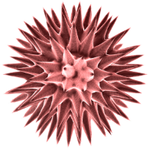
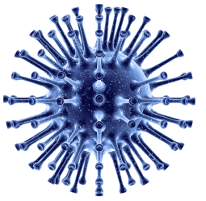
Name:
Please tick as many answers as appropriate
Vaccines are used to: |  |  | Vaccines can be effective against:
Prevent infections | X |  | Bacterial infections
Treat infections |  |  | Viral infections
Postpone infections |  |  | Both bacterial and viral infections | X
 |  |  | Neither bacterial or viral infections

By getting vaccinated you can: |  |  | Vaccines are made up of:
Protect yourself | X |  | Antibodies
Protect people around you | X |  | White blood cells
Protect your useful microbes | X |  | Weak or inactive versions of the microbe that makes us ill | X
 |  |  | Strong microbes that make us ill

How do vaccines work? |  |  | Herd immunity is:
They block the entry of microbes in the body |  |  | When animals such as cattle have been vaccinated
They kill microbes in your body |  |  | A type of immunity naturally present in the body
The immune system attacks the vaccine and remembers for next time | X |  | When enough of the population is vaccinated to prevent the spread of | X
 |  |  | None of the above
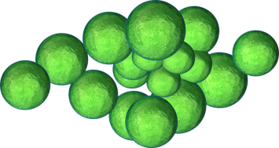

Which diseases cannot be prevented by vaccination? |  |  | Which diseases are eradicated or rare thanks to vaccinations?
Common cold | X |  | Smallpox | X
Measles |  |  | Cough
Sore throat | X |  | Polio | X
Polio |  |  | Tetanus | X

